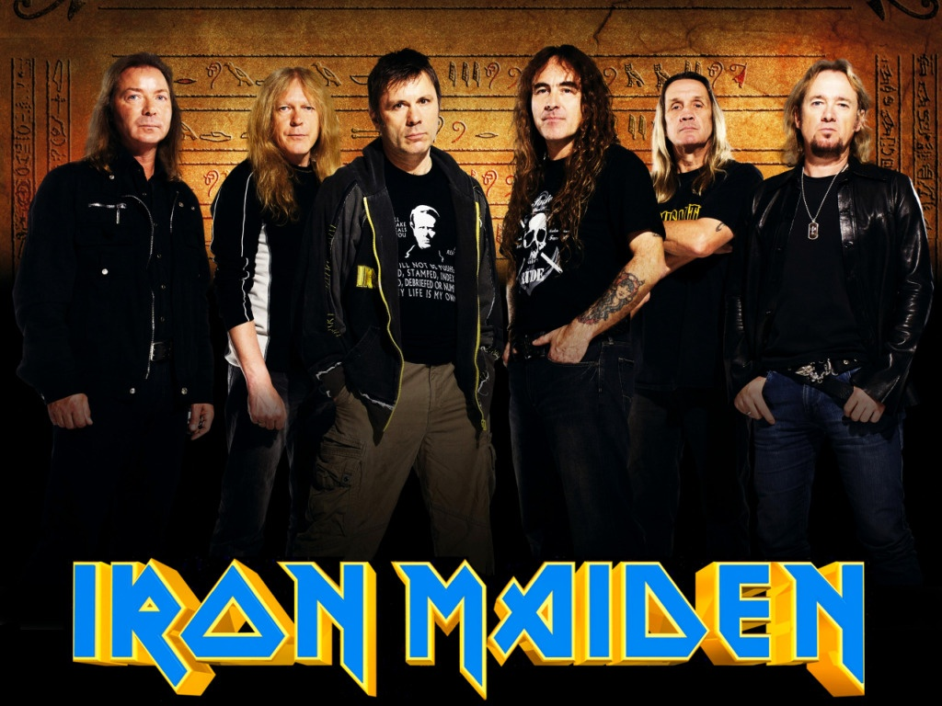

**Iron Maiden** are an English [heavy metal](https://en.wikipedia.org/wiki/Heavy_metal_music) band formed in [Leyton](https://en.wikipedia.org/wiki/Leyton), east London, in 1975 by bassist and primary songwriter [Steve Harris](https://en.wikipedia.org/wiki/Steve_Harris_(musician)). The band's [discography](https://en.wikipedia.org/wiki/Iron_Maiden_discography) has grown to thirty-seven albums.

Iron Maiden achieved initial success during the early 1980s. The band released a series of UK and US platinum and gold albums, Since the return of [lead vocalist](https://en.wikipedia.org/wiki/Lead_vocalist) [Bruce Dickinson](https://en.wikipedia.org/wiki/Bruce_Dickinson) and guitarist [Adrian Smith](https://en.wikipedia.org/wiki/Adrian_Smith) in 1999, the band became again very popular. Their album, [*The Book of Souls*](https://en.wikipedia.org/wiki/The_Book_of_Souls), was released on 4 September 2015.

Despite little radio or television support, Iron Maiden are considered one of the most successful heavy metal bands in history, the band have sold over 90 million albums worldwide. The band won the [Ivor Novello Award](https://en.wikipedia.org/wiki/Ivor_Novello_Awards) for international achievement in 2002. As of October 2013, the band have played over [2000 live shows](https://en.wikipedia.org/wiki/List_of_Iron_Maiden_concert_tours) throughout their career. For the past 35 years, the band have been supported by their famous mascot, "[Eddie](https://en.wikipedia.org/wiki/Eddie_the_Head)", who has appeared on almost all of their album and single covers, as well as in their live shows.

**Answer questions about Iron Maiden *medium***

In which part of England did the band form?

_____________________________________________

When did they have their first success?

_____________________________________________

When was their last album released?

_____________________________________________

Do they have a lots of support from the radio and TV?

_____________________________________________

How many years have they been accompanied by „Eddie“?

_____________________________________________

What happened in 1999?

________________________________________________________________________________________________________

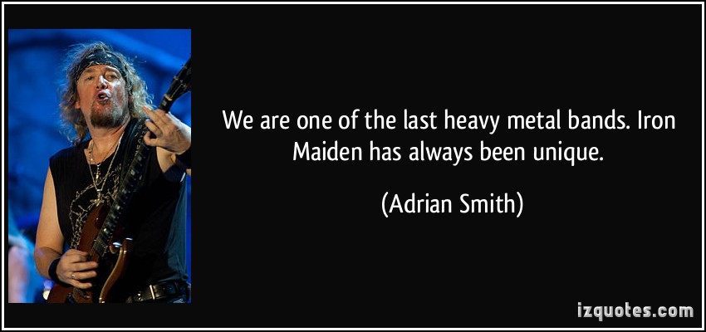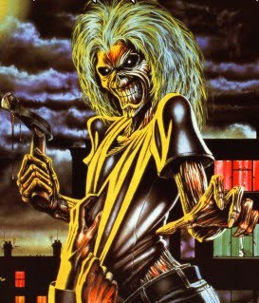

**Answer questions about Iron Maiden *easy***

When did the band form?

_____________________________________________

How many albums did they make?

_____________________________________________

What is the name of thein lead quitarist?

_____________________________________________

How many albums did they sell around the world?

_____________________________________________

What is the name of thein mascot?

_____________________________________________

How many live shows have they played? (until October 2013)

____________________________________________________



[**Iron Maiden**](https://www.lyricsfreak.com/i/iron+maiden/)**– Fear Of The Dark *medium***  
  
I am a man who ­­___________________ alone  
And when I'm ___________________ a dark road  
At night or ___________________ through the park  
When the light ___________________ to change  
I sometimes ___________________ a little strange  
A little anxious when it's dark  
  
***Chorus: choose the correct word***

Fill in the verbs:

STROLLING

WALKS

FEEL

WALKING

BEGINS

*Fear of the dark, fear of the dark  
I have a constant fear* ***what / that*** *something's  
Always near  
Fear of the dark, fear of the dark  
I have a phobia that someone's  
Always* ***there / here***  
  
Have you ___________________ your fingers down  
The wall  
And have you ________________your neck skin crawl  
When you're SEARCHING for the light?  
Sometimes when you're scared  
To ___________________ a look  
At the corner of the room  
You've sensed that something's  
___________________ you  
  
Have you ever been alone at night  
___________________ you heard footsteps behind  
And ___________________ around and no one's there?  
And as you quicken up your pace  
You _______________ it hard to ______________again  
Because you're sure there's  
Someone there  
  
___________________ horror films the night before  
Debating witches and folklore  
The unknown troubles on your mind  
Maybe your mind is ___________________ tricks  
You sense, and suddenly eyes fix  
On ___________________ shadows from behind  
  
***Chorus:*** *Fear of the dark….*

Fill in the verbs:

PLAYING

WATCHING

DANCING

Fill in the verbs:

FELT

TAKE

RUN

WATCHING

Fill in the verbs:

THOUGHT

FIND

LOOK

TURNED

When I'm walking a dark road  
I am a man who walks alone

[**Iron Maiden**](https://www.lyricsfreak.com/i/iron+maiden/)**– Fear Of The Dark *easy***

***Choose the correct words:***

I am a man who **walks / runs** alone  
And when I'm walking a dark road  
At night or strolling through the **school / park**  
When the light begins to change  
I sometimes feel a **little / big** strange  
A little anxious when it's dark  
  
***Chorus:***

*Fear of the dark, fear of the dark  
I* ***have / can*** *a constant fear that something's  
Always near  
Fear of the dark, fear of the dark  
I* ***have / can*** *a phobia that someone's  
Always there*  
  
Have you run your fingers **down / up**  
The wall  
And have you felt your neck skin crawl  
When you're searching for the light?  
Sometimes when you're **angry / scared**  
To take a look  
At the corner of the room  
You've sensed that something's  
Watching **you / me**  
  
Have you ever been alone at night  
Thought you heard footsteps **behind / in the front**  
And turned around and no one's there?  
And as you quicken up **my / your** pace  
You find it hard to look again  
Because you're sure there's  
Someone **there / here**  
  
Watching horror films the night **before / after**  
Debating witches and folklore  
The unknown troubles on your mind  
Maybe **your / my** mind is playing tricks  
You sense, and suddenly eyes fix  
On dancing shadows from **the front / behind**  
  
***Chorus:*** *Fear of the dark….*

When I'm walking a dark road  
I am a man who walks alone